**Tops Technologies**

**Software Engineering Assignment**

**MODULE: 1 (SDLC)**

1.) What is software? What is software engineering?

->Software is a collection of instructions, data, or computer programs that are used to run machines and carry out particular activities

Software engineering is the systematic approach to designing, developing, testing, and managing software systems. Software engineering involves the implementation of computer science, engineering principles, and mathematical concepts to create, test, and analyse software applications and systems that are efficient, reliable, and secure.

2.) Explain types of software.

->Types of Software

1.Application software

The most frequently used software is application software, which is a computer software package that performs a specific function for a user or, in some cases, for another application. An application can be self-contained, or it can be a group of programs that run the application for the user.

Examples :- graphics software, databases

2.System software.

. These software programs are designed to run a computer's application programs and hardware. System software coordinates the activities and functions of the hardware and software. In addition, it controls the operations of the computer hardware and provides an environment or platform for all the other types of software to work in.

Examples :-operating system

3.Driver software.

Also known as device drivers, this software is often considered a type of system software. Device drivers control the devices and peripherals connected to a computer, helping them perform their specific tasks. Every device that's connected to a computer needs at least one device driver to function

Examples :- keyboards,

4.Middleware.

. The term middleware describes software that mediates between application and system software or between two different kinds of application software

.Examples :- Excel and Word.

5.Programming software.

Computer programmers use programming software to write code. Programming software and programming languages, such as Java or Python, let developers develop, write, test and debug other software programs.

Examples :- compilers,

3.) What is SDLC? Explain each phase of SDLC

-> Software Development Life Cycle (SDLC)

The software development lifecycle (SDLC) is the cost-effective and time-efficient process that development teams use to design and build high-quality software.

1 PLANNING

2 ANALYSIS

3 DESIGNING

4 IMPLEMENTATION

5 TESTING

1.In the Software Development Life Cycle (SDLC), **Planning** is the phase where project goals, scope, and requirements are defined. It involves detailed discussions and analyses to understand the project's objectives, feasibility, resources, and risks. The outcome of this phase is a comprehensive project plan that serves as a roadmap for the subsequent stages of development, ensuring the project is well-organised and aligned with stakeholders' expectations.

2.**The Analysis** phase involves gathering detailed information about the system requirements from stakeholders to ensure a thorough understanding of what the software needs to achieve. This phase includes identifying and documenting functional and non-functional requirements, analysing the needs and expectations of users, and creating detailed specifications and models that describe how the system should behave. The goal of the analysis phase is to produce a clear, detailed requirement specification that guides the design and development of the software.

3**.The Designing** phase is where the system's architecture and components are planned out in detail. This phase translates the requirements gathered during the analysis phase into a blueprint for constructing the software. It involves creating design documents, including system architecture diagrams, data models, interface designs, and detailed specifications for each component. The goal is to define how the system will be structured and how the components will interact, ensuring the software meets the specified requirements and is scalable, reliable, and maintainable.

4.**The Implementation** phase is where the actual coding and development of the software takes place. During this phase, developers write the code according to the design specifications created in the previous phase. This involves using programming languages and tools to build the software's components, integrate them, and ensure they function as intended. The implementation phase turns the planned designs and requirements into a working software application. The goal is to produce a functional, testable, and complete software product that meets the defined requirements.

5.**The Testing** phase involves systematically evaluating the software to ensure it meets the specified requirements and functions correctly. This phase includes various testing activities such as unit testing, integration testing, system testing, and acceptance testing. The purpose is to identify and fix bugs or issues, verify that the software performs as expected, and ensure it is reliable, secure, and ready for deployment. The goal is to deliver a high-quality software product that fulfils user needs and operates smoothly in its intended environment.

4.)What is DFD? Create a DFD diagram on Flipkart.

->A **Data Flow Diagram (DFD)** is a visual representation of how data moves through a system. It shows the flow of information from inputs to outputs, detailing where the data comes from, how it is processed, and where it goes. In simple words, a DFD helps to understand how information flows in a system and how the system processes that information. It's like a map that shows how data travels and transforms within a system.

**Data Flow Diagram on Flipkart**

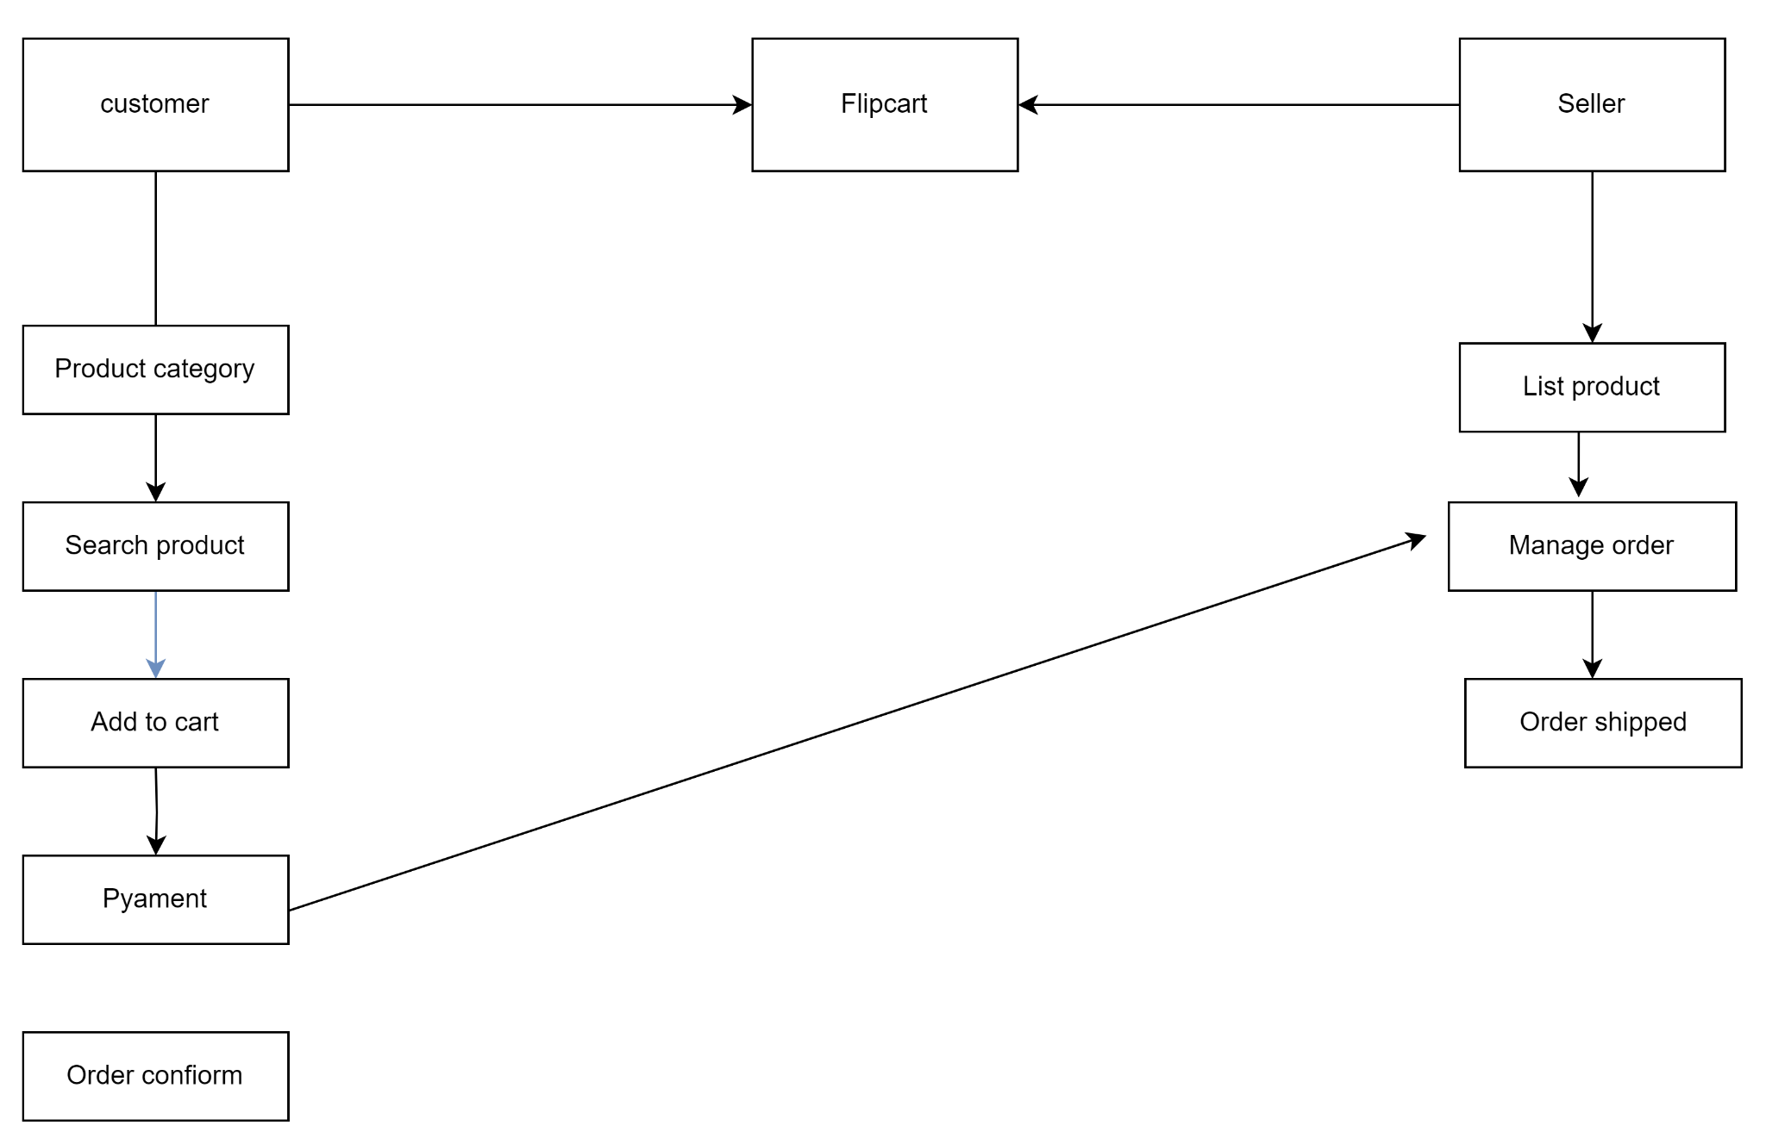

4.)What is Flow chart? Create a flowchart to make addition of two numbers

->A flowchart is a visual representation of a process or algorithm. It uses standardised symbols to depict the steps involved in a process, the order in which they occur, and the flow of data or control through the system. Flowcharts are commonly used in various fields, including programming, business process modelling, and project management, to simplify complex processes and enhance understanding.

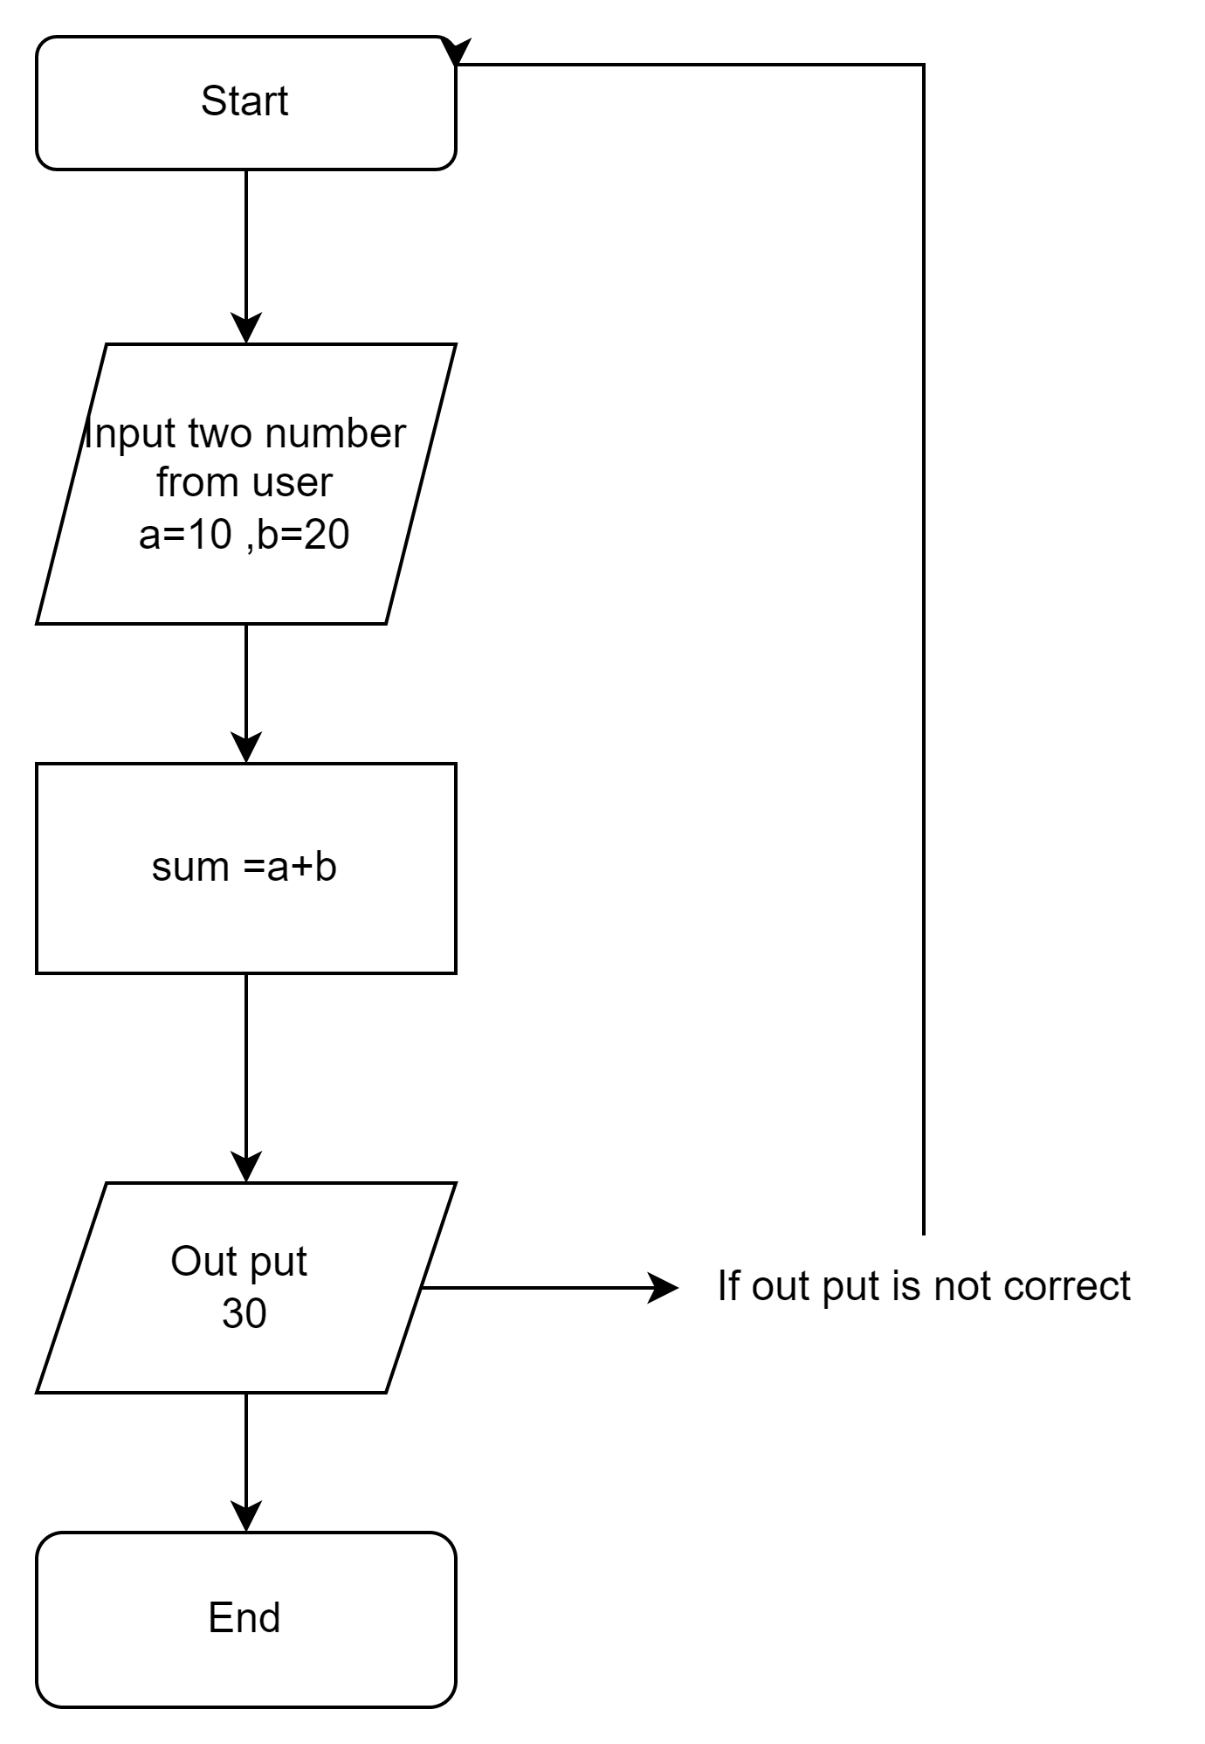

## **Explanation of the Flowchart Steps:**

1. Start: The process begins.
2. Input Number A: The user is prompted to enter the first number (A).
3. Input Number B: The user is prompted to enter the second number (B).
4. Sum Calculation: The two numbers are added together, and the result is stored in a variable (Sum).
5. Output Sum: The result (Sum) is displayed to the user.
6. End: The process concludes.

6.)What is Use case Diagram? Create a use-case on bill payment on paytm.

->A use case diagram is a visual representation that illustrates the interactions between users (actors) and a system, highlighting the various use cases that the system supports. It helps in understanding the functional requirements of the system from the user's perspective and is a key component of the Unified Modeling Language (UML). Use case diagrams typically consist of actors, use cases, and the relationships between them, providing a high-level overview of how users will interact with the system without detailing the implementation.

## Use Case Diagram for Bill Payment on Paytm

Here is a simplified use case diagram for the bill payment process on Paytm:

## 

## 

## Explanation of the Use Case Diagram

* Actors:
  + User: The person making the bill payment.
  + Bank: The financial institution that processes the payment.
* Use Cases:
* The primary action where the user initiates the payment.
  + View Transactions: Allows the user to see past transactions.
  + Add Payment Method: The user can add or update their payment methods.
  + Receive Confirmation: The user receives a confirmation of the payment.